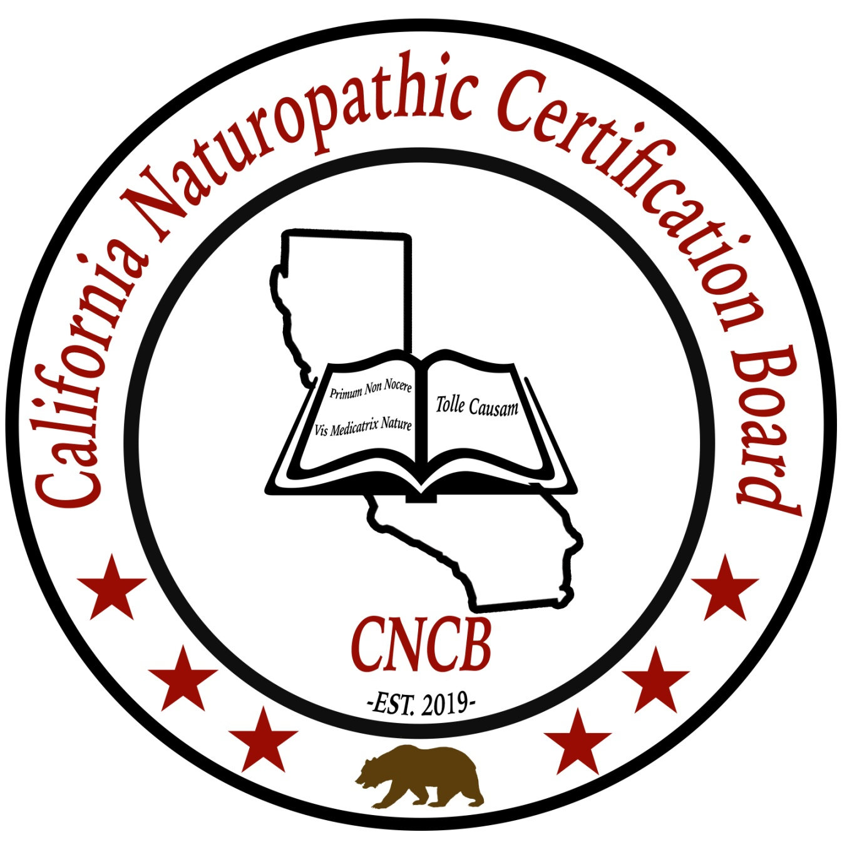
Board Certification Application Packet

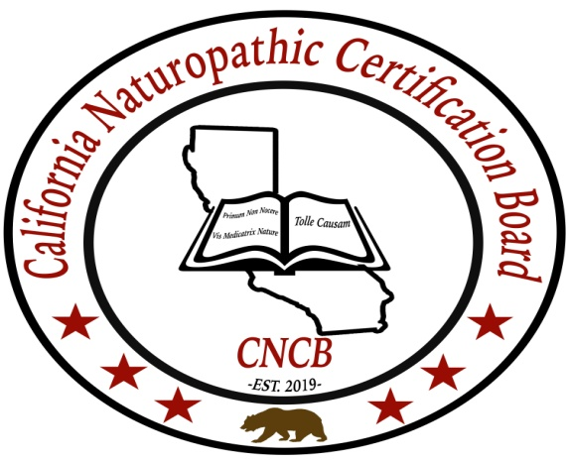
Requirements for Board Certification
Candidates for certification must have attained the following requirements before taking the proctored certification exam.
- Having graduated from a board approved Naturopathic College that is either state licensed as a vocation school or college accredited by the American Naturopathic Medical Accreditation Board.
- Naturopathic education hours in didactic or online education must total no less than 2500 hours of traditional naturopathic education.
- Having an internship in an approved naturopathic residency program or clinic approved by the board with no less than 500 hours of clinical contact. (Exemptions will be made if the candidate can prove that he or she has been in practice for a minimum of 2 years prior to the creation of the board *2019).
- Successfully passing the California Naturopathic Board Exam (CNBE) with a grade of 80 or higher.
- Proof of professional Malpractice and general liability for coverage of no less than $250,000.
Board Certification Checklist
Please include the following items for review of your application by the board. Incomplete applications will not be accepted and returned to you.
[] Attach all copies of transcripts of the naturopathic college program you attended and graduated from or equivalent. If the college is no longer active please send a copy of your degree or diploma.
[] A passport size photograph
[] A copy of a state or federally issued identification
[] 2 professional references
[] Proof of professional and or liability insurance of no less than $250,000 in coverage.
[] Notarized copy of application signed and certified by a public notary.
[] Application Fee of $50 paid by check, money order or credit card to California Naturopathic Certification Board (non refundable)
[] Test fee of $500 paid by check, money order or credit card
Paid to California Naturopathic Certification Board. In the event that you do not qualify for certification the $500 check or money order will be returned to you.
Board Certification Application

First Name:___________________________________
Middle Name:_________________________________
Last Name:___________________________________
Date:____________________________
Home Address:_________________________________
Business Address: (If Applicable)
_________________________________________________
Date of Birth:__________
Place of Birth:_______________________________________
Email:_____________________________________________
SSN or TIN____________________________
1.Are you a California Resident? [] Yes [] No
2.Have you ever been convicted of a felony ?[]Yes[]No
(If you marked yes, please attach the reason why on a separate page.)
3.Have you ever had a license, registration or certification pertaining to naturopathy revoked for any reason? []Yes [] No (If you marked yes please attach the reason why on a separate page.)
4. Have you ever voluntarily surrendered a license, registration or certificate after formal charges were brought against you? [] Yes []No (If you marked yes, please explain on a separate sheet of paper).
5. Do you have any physical or mental disability that might interfere with your ability to practice naturopathy? [] Yes [] No (If you marked yes, please explain on a separate sheet of paper).

Notarization and Agreement
_______________________________
I am applying to the California Naturopathic Certification Board, because it is my desire to show competence through board certification. I understand that the CNCB is at this time a non- governmental certification board. I agree to abide by the articles, scope and code of ethics of this board and understand that failure to do so may lead the board to removal of certification.
I understand that the application fee will not be waived if my application is returned and that testing if not passed is non refundable.
Applicant Signature___________________________________________________
Sworn before met this___________________ day of________________20______
Notary public___________________________ Commission Expires_________________
Payment and mailing
Payment and mailing of packet should be made to

California Naturopathic Certification Board
28562 Oso Pkwy Ste. D #227
Rancho Santa Margarita CA 92688

If paying by card
Name as shown on card:_______________________________
Billing Address:______________________________________
Credit Card Number:__________________________________
Expiration date:__________
Verification Code on back of card:________________________
By signing I am allowing the CNCB to charge your card for $ _____________
Signature:_______________________________

